LAB 4.3
Task 1: Zero-Shot Prompting – Leap Year Check
Scenario: Zero-shot prompting involves giving instructions without providing examples.
Prompt used: # generate a zero shot prompting python program whether the given year is leap year or not
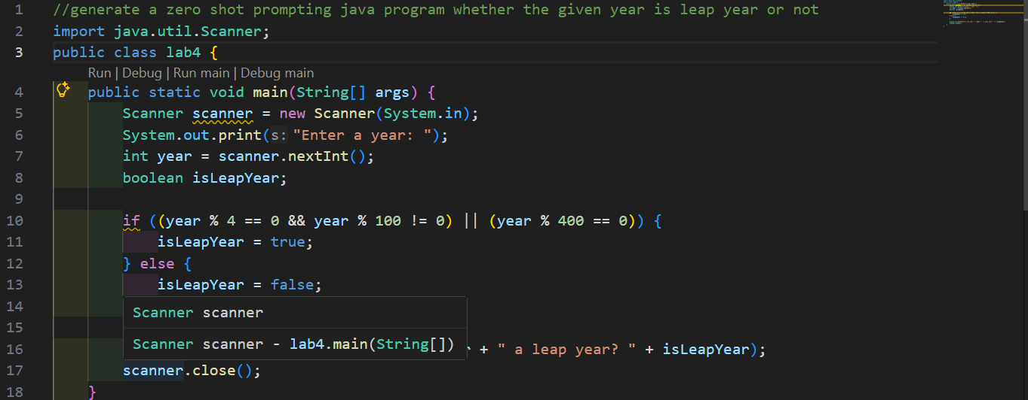
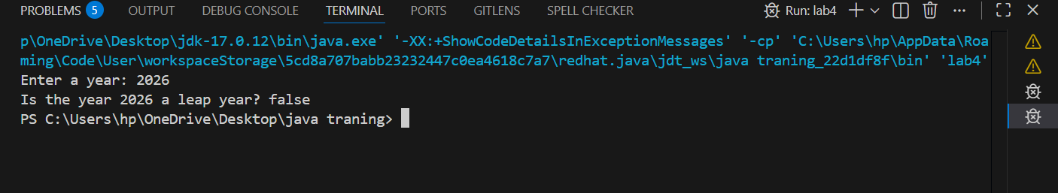

Task 2: One-Shot Prompting – Centimeters to Inches Conversion
Scenario: One-shot prompting guides AI using a single example.
Prompt used: # generate a one shot prompting python prorgram which converts centimeter to inches and use the correct mathematical formula
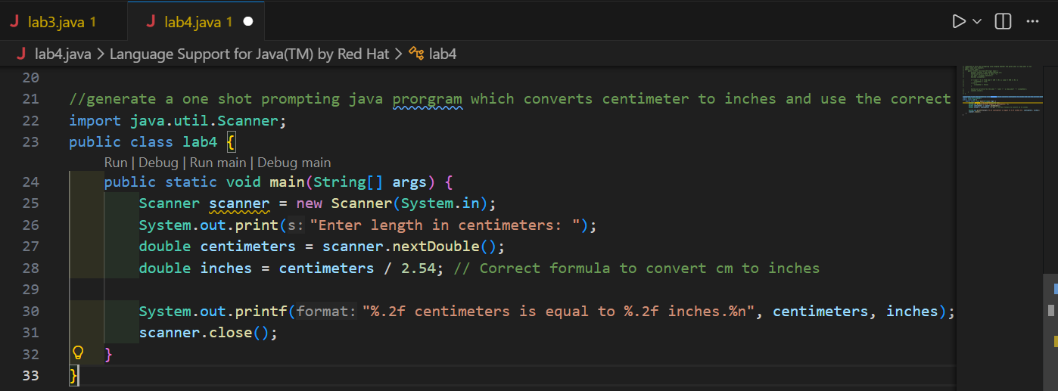
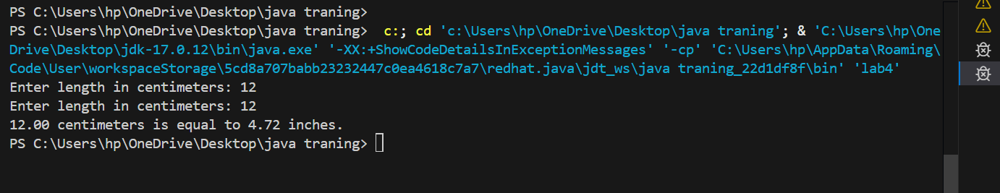

Task 3: Few-Shot Prompting – Name Formatting
Scenario: Few-shot prompting improves accuracy by providing multiple examples.
Prompt used: #write a python function that accepts a full name as input and format it as last and first name
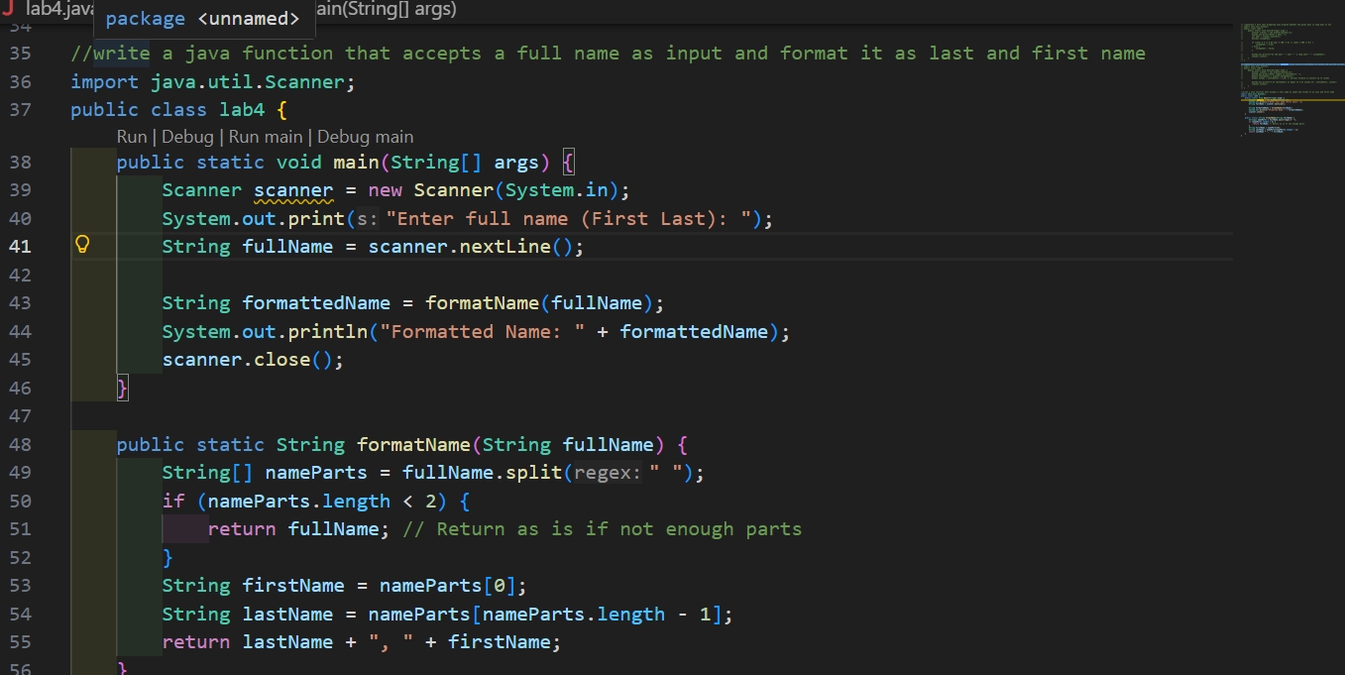
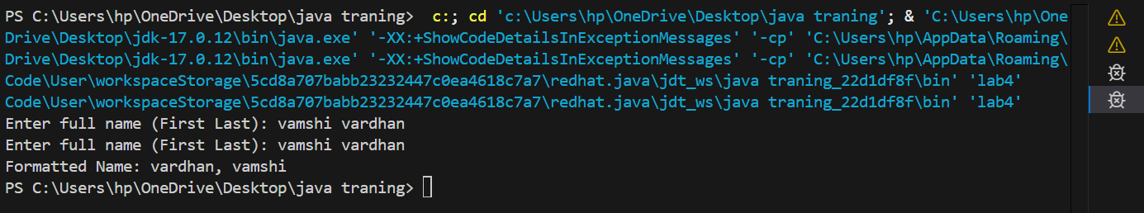

Task 4: Comparative Analysis – Zero-Shot vs Few-Shot
Scenario: Different prompt strategies may produce different code quality.
Prompt used: # write a python function that:
#accepts a string as input
#count the number of vowels both uppercase and lowercase
#return vowel count
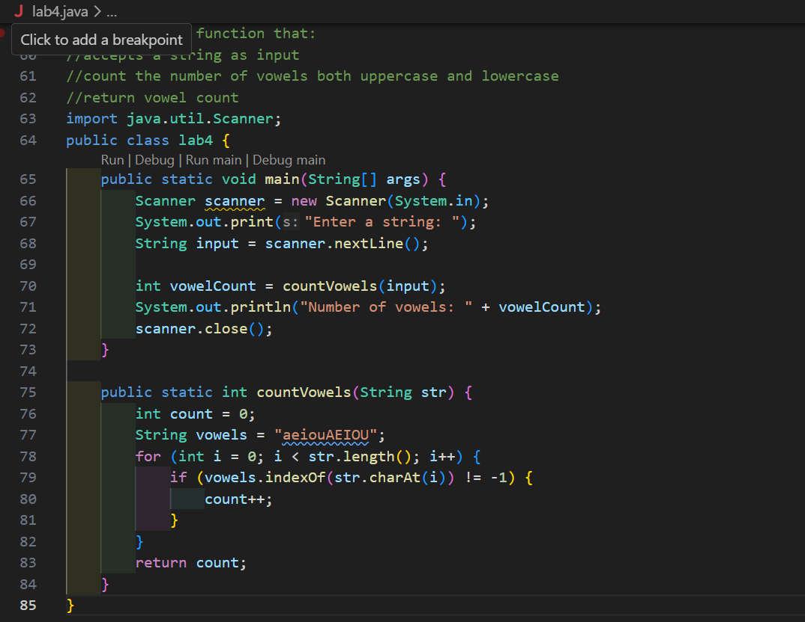
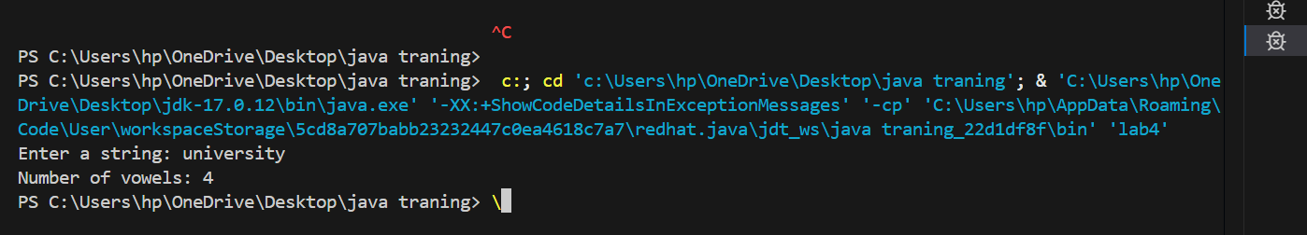

Task 5: Few-Shot Prompting – File Handling
Scenario: File processing requires clear logical understanding.
Prompt used: # write a python function that reads a text.file and counts the number of lines in the file and return line count
